Cadrian Chan  Liwen Zhang | E-ZeePass  User Manual
Washington University in St. Louis |  | April 2009

Contents
1 User Manual 3
1.1 User Requirements: 3
1.2 Procedures: 3

1 User Manual
The user manual walks a user through all the necessary steps, procedures and requirements for using the E-ZeePass service.

1.1 User Requirements:

ASP compatible browsers, such as Internet Explorer, Firefox, Chrome.

E-ZeePass is a web-based application. The required software and hardware specifications are minimal.

1.2 Procedures:

Step 1)
a) Go to the E-ZeePass website from your favorite browser.
b) Enter the web address of your login account. It will be automatically converted to its domain name.
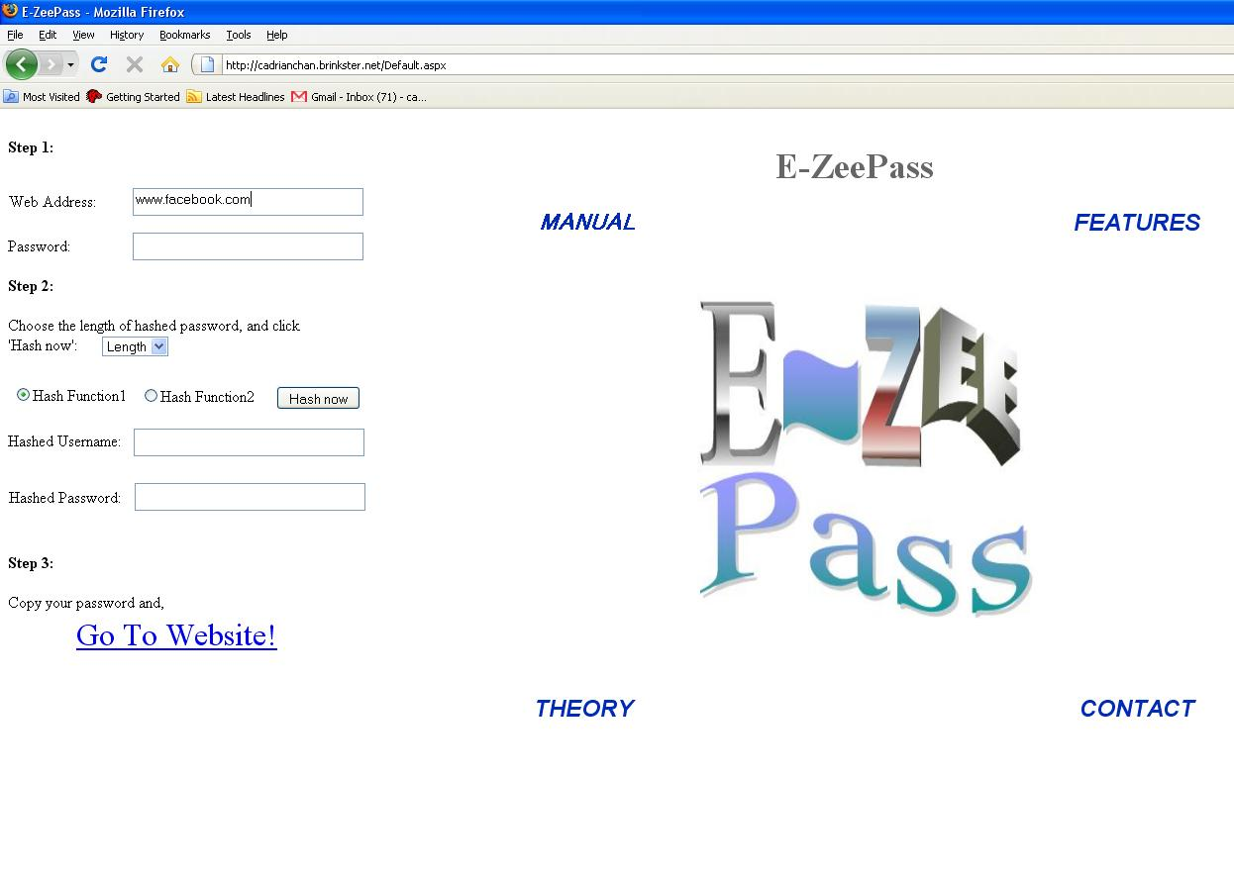

Figure 1. Entering Web Address

c) The following example shows the address www.facebook.com is converted to facebook.com

d) Create and enter your master password. This is the single password you need to remember from now on.
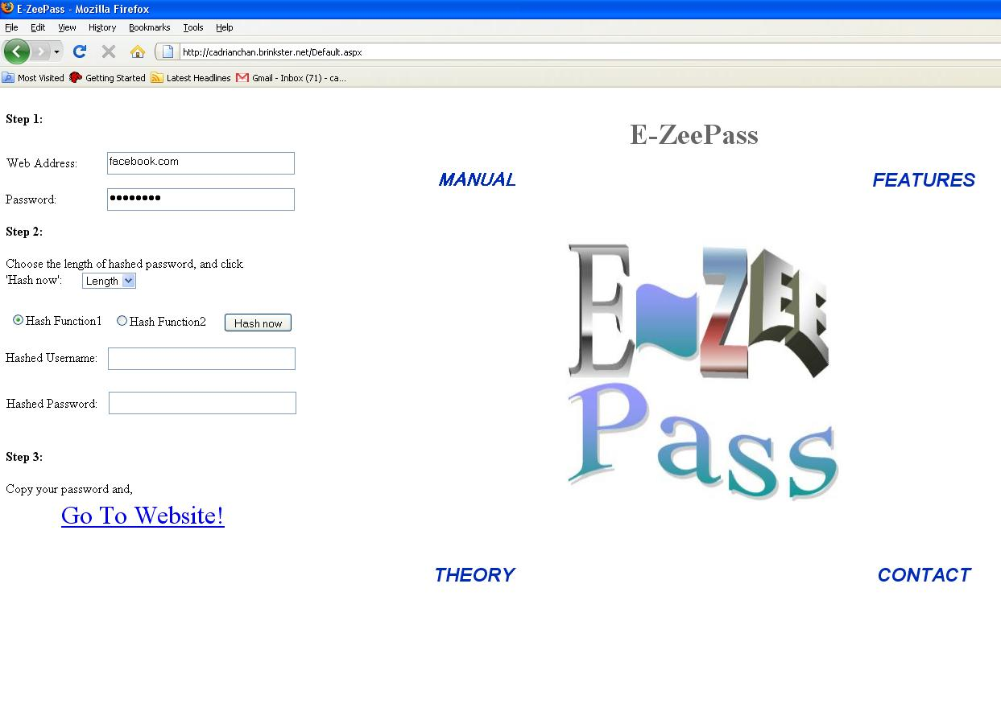
Figure 2. Entering Password

Step 2)
a) Variable password length: Use the dropdown list to choose the desired length of your hashed password, such as “10” in the following example.

b) Select your hash function - “Hash Function 1” uses MD5 and “Hash Function 2” uses SHA-512. The actual algorithm is not displayed for security reasons.

c) Click the “Hash now” button, and the hashed username and password will be generated as shown:
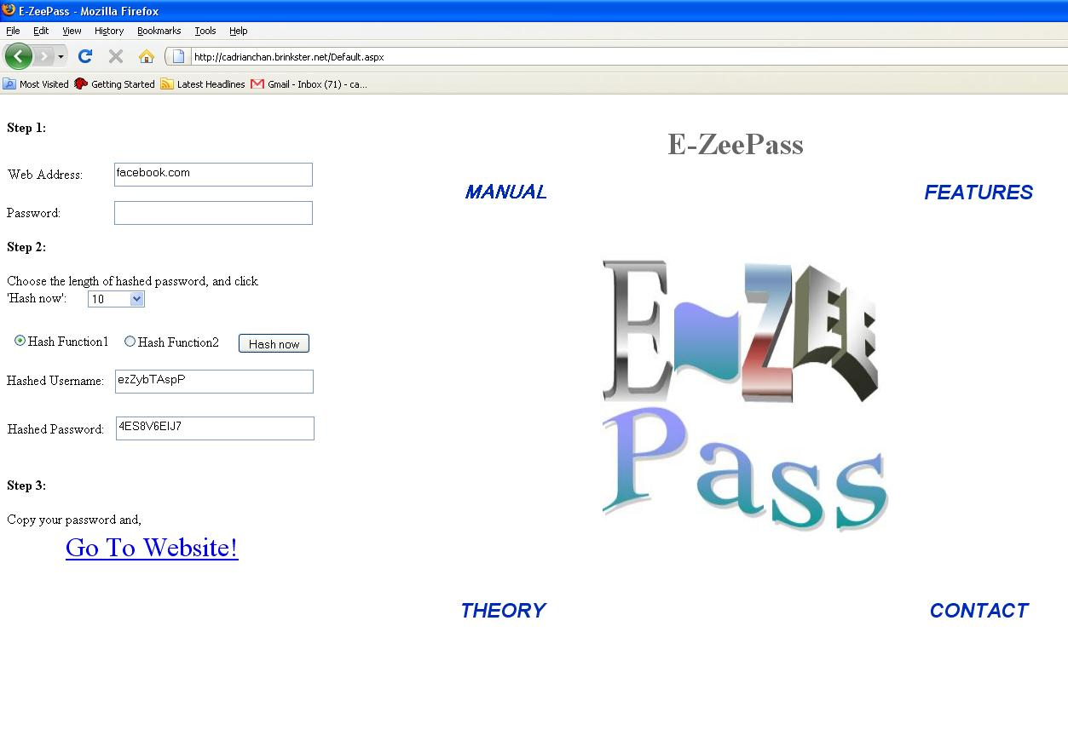
Figure 3. Generating hashed password and username

Step 3)

a) Click on “Go to Website!” to navigate to your desired login page using the frame on the right hand side.

b) Copy and paste your password into the corresponding field of the login site:
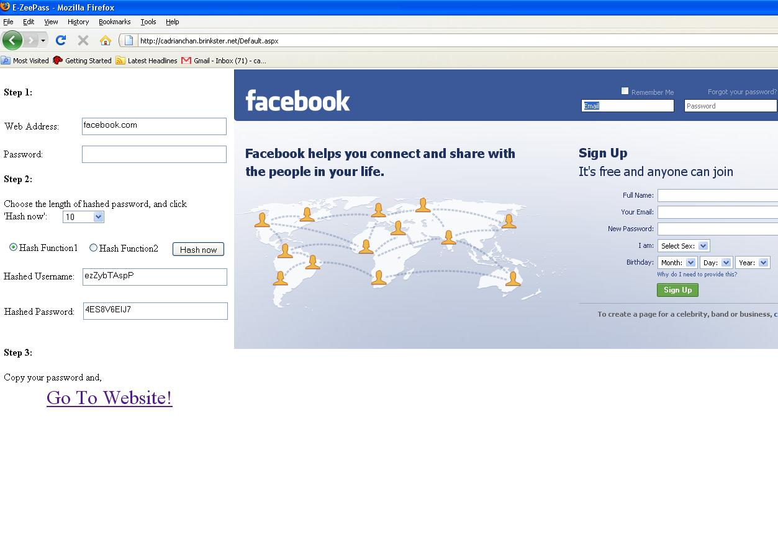
Figure 4. Navigating to login page

That is all there is to using E-ZeePass! It is meant to be a quick and easy way for users to manage their passwords. User can navigate their login account within the iframe, or in a new tab/window if they prefer.

