SOFTWARE MANUAL

NET VIGILANT

NETWORK MONITOR

V1.1
Printed On: 3rd Dec 2007
C:\Washington University\SoftwareUserManual.docx

Department Of Computer Science & Engineering

Washington University in Saint Louis

Submitted By

Subharthi Paul
Madhuri Kulkarni

Table of Contents

1 | INTRODUCTION | 3
1.1 | Project Overview_____________________________________________________ | 4
2 | REQUIREMENTS | 5
2.1 | Software Requirements________________________________________________ | 6
2.2 | Hardware Requirements_______________________________________________ | 6
3 | APPLICATION WORK FLOW | 7
3.1 | Packet Capture_______________________________________________________ | 8
3.2 | Packet Filtering _____________________________________________________ | 9
3.3 | Network Utilities_____________________________________________________ | 12
3.4 | Packet Save/Retrieve__________________________________________________ | 18
3.5 | Exit Application_____________________________________________________ | 20
4 | ADDITIONAL INFORMATION | 21
4.1 | Definitions, Acronyms and Abbreviations_________________________________ | 22
4.2 | References_________________________________________________________ | 22

INTRODUCTION

INTRODUCTION
  - Project Overview:
The main use of this application is for capturing packets, storing them for analysis and retrieving them later again if needed.
Following functionalities have been implemented.
Basic Functionality:
- Network Monitor [Packet capture]
This feature provides the facility to capture network packets. These packets will be parsed and the packet header details will be listed in a table. The packets can be stored in XML (Extensible Markup Language) serialized formats. These packets can be retrieved later for viewing and analysis.
- Packet Filtering
The captured packets can be filtered to display according to the packet type.
The packets can be filtered by protocol type TCP (Transmission Control Protocol), UDP (User Datagram Protocol), ARP (Address Resolution Protocol), ICMP (Internet Control Message Protocol) and IGMP (Internet Group Management Protocol).

- Network Utilities [Ping, TCP Statistics, UDP Statistics]
The above mentioned utilities are implemented for network traffic analysis.

- Packet Analysis
The detailed packet information is displayed.

- Graphical Interface
We have implemented an easy to use Windows based graphical user interface.

REQUIREMENTS

- REQUIREMENTS
- NET Vigilant Setup File
- WinPcap V4.0.1 must be installed.
WinPcap is the industry-standard tool for link-layer network access in Windows environments: it allows applications to capture and transmit network packets bypassing the protocol stack, and has additional useful features, including kernel-level packet filtering, a network statistics engine and support for remote packet capture.
WinPcap consists of a driver that extends the operating system to provide low-level network access, and a library that is used to easily access the low-level network layers. [1]
2.2 Hardware Requirements:
Following devices are required:
- Pentium IV and upward processor
- Monitor
- Keyboard, mouse
- 1 GB RAM
- 1.5 MB of hard disk space

Software Dependencies:
Installation of WinPcap V4.0.1 is necessary for the software to work on the computer.
Hardware Constraints:
Not all wireless network adaptor cards support packet capture. Make sure your wireless network interface card supports promiscuous mode for packet capture.
Hence this software may not work on all wireless network interface cards. But it will capture packets on Ethernet networks.

APPLICATION WORKFLOW

  - APPLICATION WORKFLOW
Installation of Net Vigilant:
- Install WinPcap V4.0.1
- Install Net Vigilant setup file by double clicking the setup.exe. Follow the instructions provided by the Installable file.
3.1 Packet Capture:
- Open application Net Vigilant by double clicking the icon.
- Double click on the any one of the listed adapters or press the “Start Sniffing” button (green arrow) after selecting the adapter.
- Packets are listed in the bottom table on the screen.
- Double click on any packet to get a detail view of the packet on the right pane.

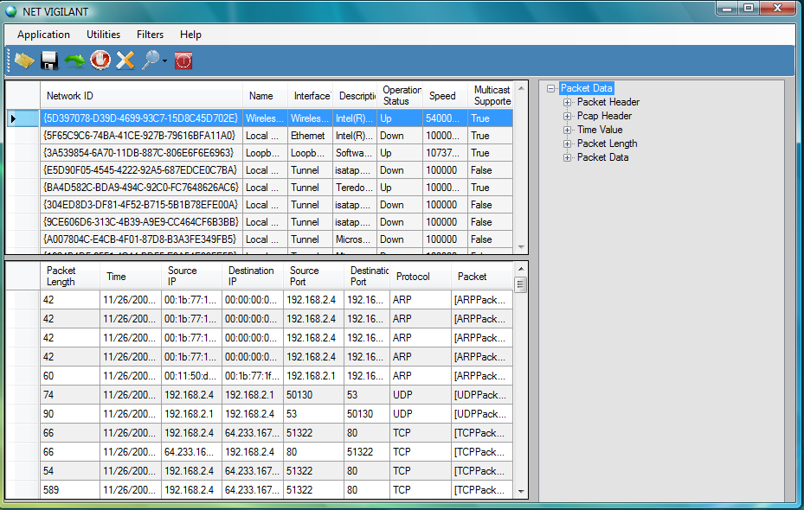
Figure 1 Packet Capture

3.2 Packet Filtering:
- Open application Net Vigilant by double clicking the icon.
Double click on the any one of the listed adapters or press the “Start Sniffing” button after selecting the adapter.
- Packets are listed in the bottom table on the screen.
- Click on “Filter -> Filter by ->” and select one of the protocols.

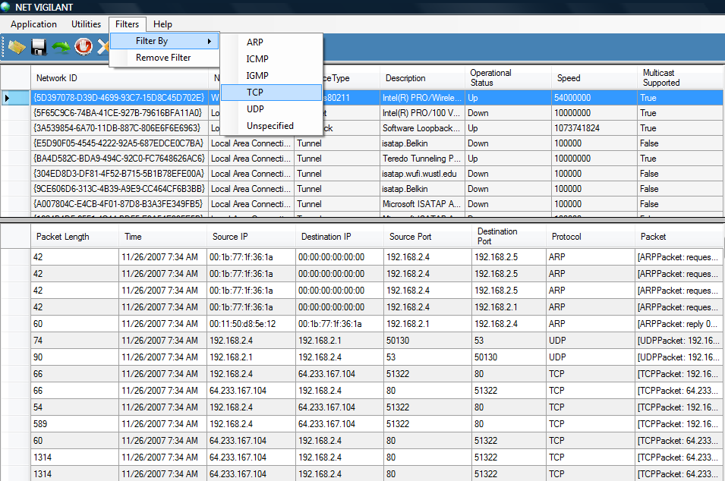

Figure 2 Packet Filtering

- The table in the bottom pane will show the selected packets if packets of that type have been captured.

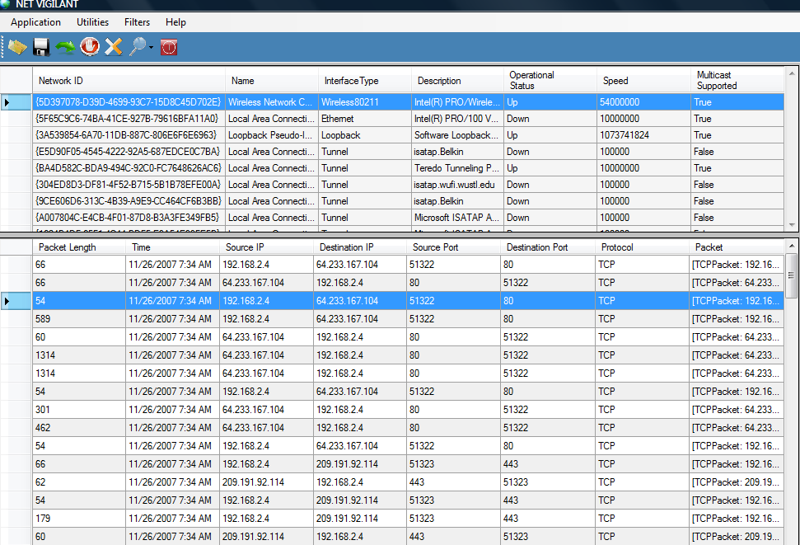
Figure 3 Packet Filtering by TCP protocol

- To remove the filter click on “Filter->Remove Filter”.

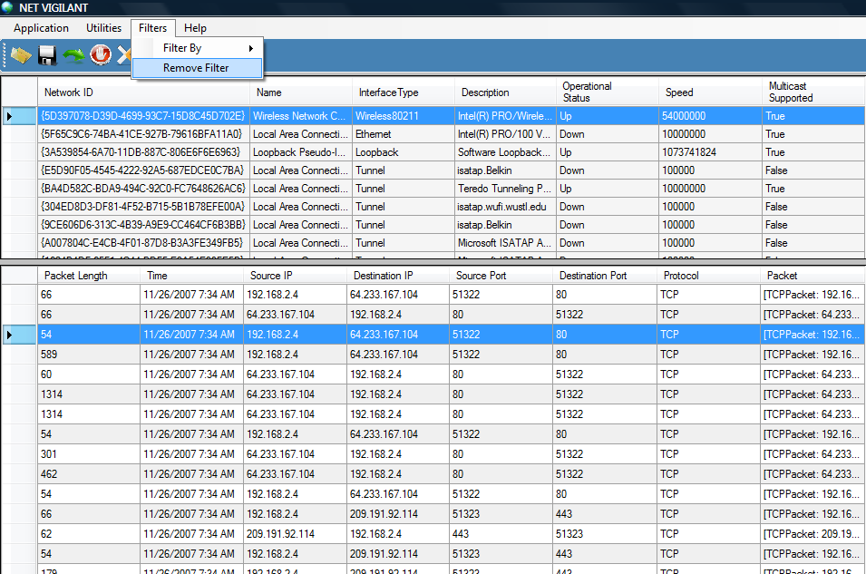

Figure 4 Remove Filtering

3.3 Network Utilities:
3.3.1 Ping:
- Open application Net Vigilant by double clicking the icon.
- Double click on the any one of the listed adapters or press the “Start Sniffing” button after selecting the adapter.
- Click on “Utilities->Ping”
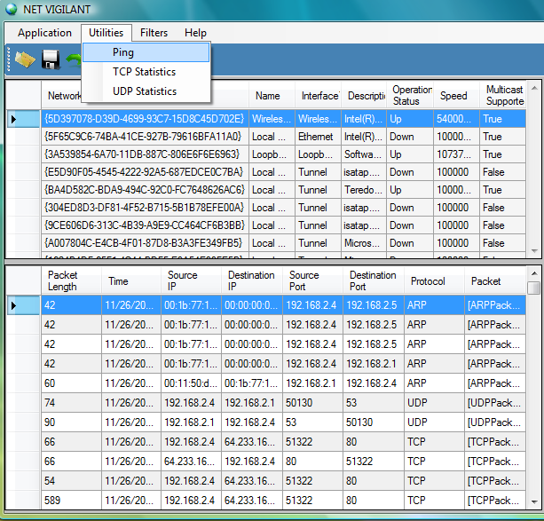
Figure 5 Ping Utility
- A Ping utility form will show up.
- Enter the IP (Internet Protocol) Address or select from the dropdown box.
- Hit the “Ping” button to view the result.
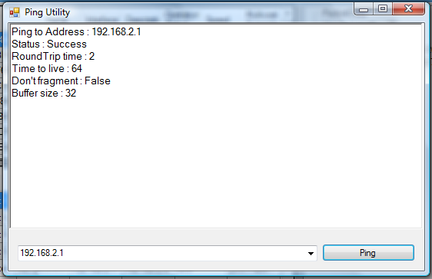
Figure 6 Ping Utility

- Result is seen above in the textbox.

3.3.2 TCP Statistics:
- Open application Net Vigilant by double clicking the icon.
- Double click on the any one of the listed adapters or press the “Start Sniffing” button after selecting the adapter.
- Click on “Utilities->TCP Statistics”

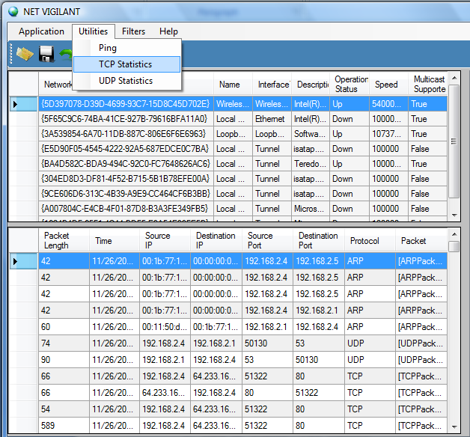
Figure 7 TCP Statistics

- A form shows up showing the TCP statistics.

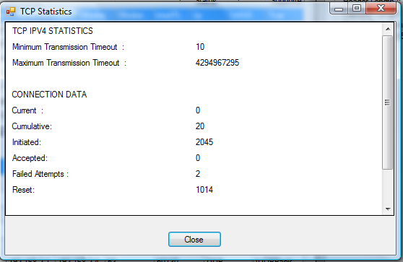
Figure 8 TCP Statistics

3.3.3 UDP Statistics:
- Open application Net Vigilant by double clicking the icon.
- Double click on the any one of the listed adapters or press the “Start Sniffing” button after selecting the adapter.
- Click on “Utilities->UDP Statistics”

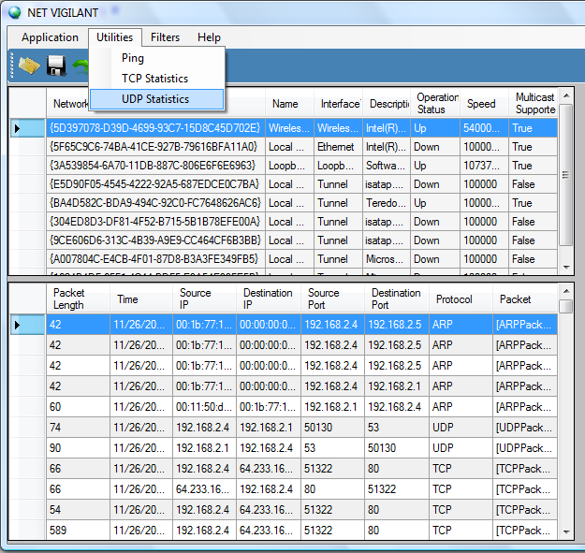
Figure 9 UDP Statistics

- A form show up showing the UDP statistics.

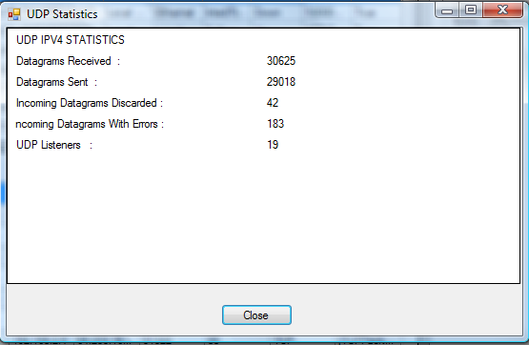

Figure 10 UDP Statistics

3.4 Packets Save/Retrieve:

- Open application Net Vigilant by double clicking the icon.
- Double click on the any one of the listed adapters or press the “Start Sniffing” button after selecting the adapter.
- Packets are listed in the bottom table on the screen.
- To save these packets either click the save icon button or click on Application->Save menu.
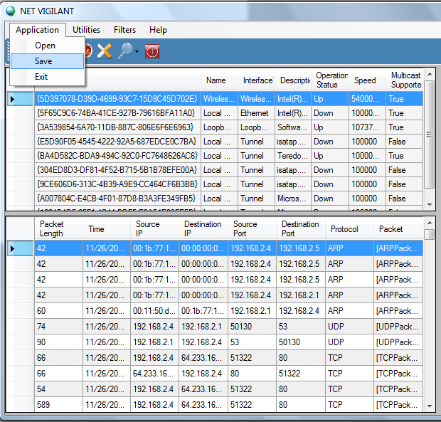
Figure 11 Save Packets

- Enter an “.XML” file to save the packets;
- You can load saved xml file later by pressing the Open file Button or by clicking Application->Open menu.
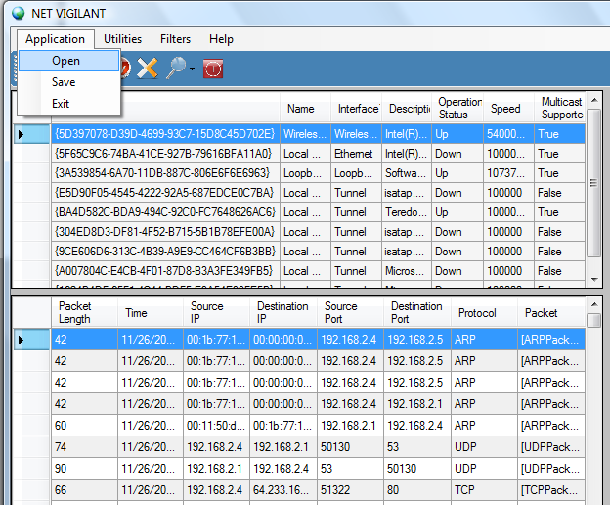
Figure 12 Open packets previously saved

5.5 Exit Application:
- Open application Net Vigilant by double clicking the icon.
- Double click on the any one of the listed adapters or press the “Start Sniffing” button after selecting the adapter.
- Packets are listed in the bottom table on the screen.
- To exit application press on stop button or click on Application->Exit.
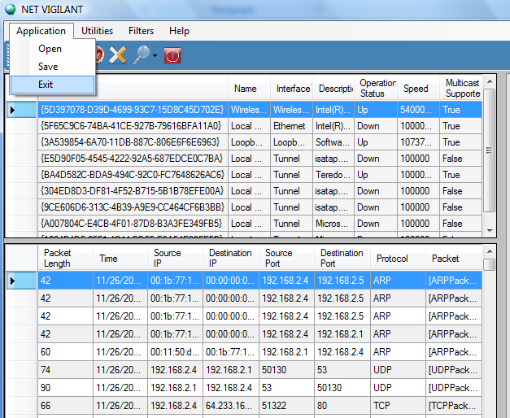
Figure 13 Exit application

ADDITIONAL INFORMATION

4 ADDITIONAL INFORMAITON

  - Acronyms

UDP | User Datagram Protocol
TCP | Transmission Control Protocol
ARP | Address Resolution Protocol
ICMP | Internet Control Message Protocol
IGMP | Internet Group Message Protocol
XML | Extensible Markup Language
GB | Gigabytes
MB | Megabytes
RAM | Random Access Memory
IP | Internet Protocol

  - References

[1] | http://www.winpcap.org/

