Power for ASUS Wireless Bridge and USB Dual Pre microphone pre-amp

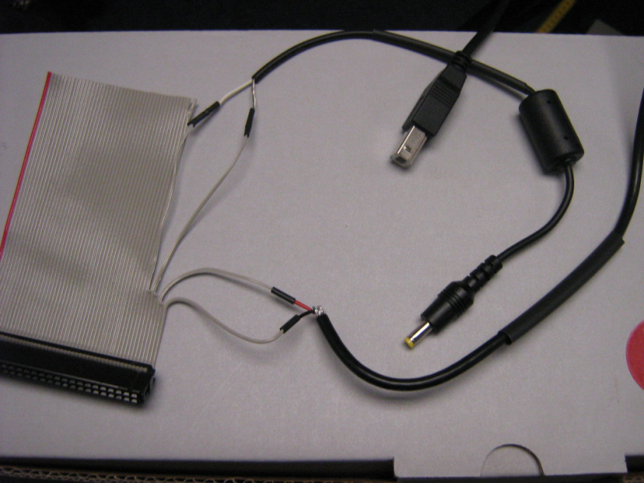

Cut of the ends of the USB cables and solder as shown. Plug ribbon cable into P5 – Pin 1 is toward center of sbRIO.