#### Please print out this form (two-sided, if you can) and write your answers legibly in the spaces provided. If you can’t write legibly, type.

###### *CSE 473 – Introduction to Computer Networks*

Review Questions for Lecture 3

##### ***Your Name****:*

##### 

1. Use the *nslookup* command to determine the IP address of shell.cec.wustl.edu, oasis.cec.wustl.edu and google.com. Write down the first IP address returned for each domain name.
2. Which is preferable from the perspective of a DNS server for a top-level domain, iterative processing, or recursive processing. Explain why.

Which is preferable from the perspective of a local DNS server? Why?

1. Here is a snapshot from Wireshark showing a DNS query and response to get the address for the onl.arl.wustl.edu.

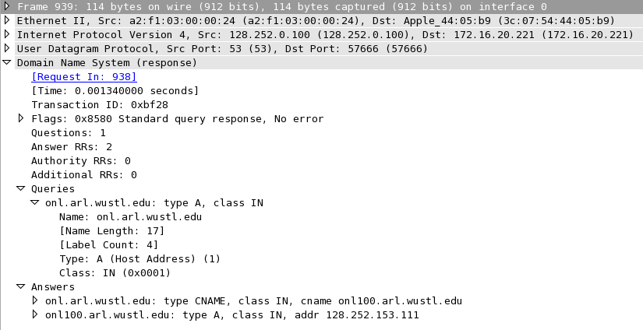

Why does the response have two answers?

What does a ‘type CNAME’ resource record tell us?

What does a ‘type A’ resource record tell us?