###### *CSE 473 – Introduction to Computer Networks*

Review Questions 24

##### ***Your Name****:*

##### 

Please print out this form (two-sided, if you can) and write your answers *legibly* in the spaces provided. If you can’t write legibly, type.

1. Explain the difference between confidentiality and integrity of messages. Can you have one without the other, and if yes, which one and why?
2. 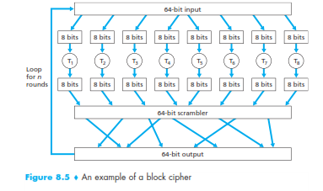In the block cipher shown in Figure 8.5 in the book, how many bits are needed to represent a key?
3. Describe two major differences between public key and secret key encryption systems, and offer an explanation for why they are often used in tandem.
4. Suppose we want to construct an RSA key pair based on the initial values *p*=5, *q*=11. Is 15 an acceptable value for *e*? Is 27? (Ignore the fact that these values are all too small.)

1. What is a DNS amplification attack? Explain why and how it works, and what defense mechanisms are available to combat it.