ORCAD/PSPICE Tutorial

Darko Ivanovich
Department of Electrical and System Engineering
Washington University in St. Louis
St. Louis, MO

September 18, 2010
Version 2.0

ORCAD is a schematic editor. In other words, it is a program that allows you to draw circuit schematics. The demo version that you have comes with a nice collection of parts libraries with parts that you are likely to use in student assignments and student laboratory exercises.
PSPICE is an electrical simulator that allows you to simulate the operation of the circuits whose schematics you prepared using ORCAD. This allows students to check for correct circuit operation even before they actually construct the circuit in the lab. The demo version of ORCAD allows you to run PSPICE without even leaving the ORCAD user interface.
You can start by clicking on START on PC Desktop and selecting Software (Old). Inside Software (Old) select ORCAD 10.5 Demo and inside this box select application Capture CIS Demo. The box shown below will pop up.
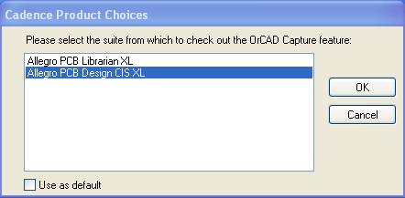
Select Allegro PCB Design CIS XL and click OK button. After the application is open click on File from the main menu bar and then select New Project. You should then see the following dialog box.
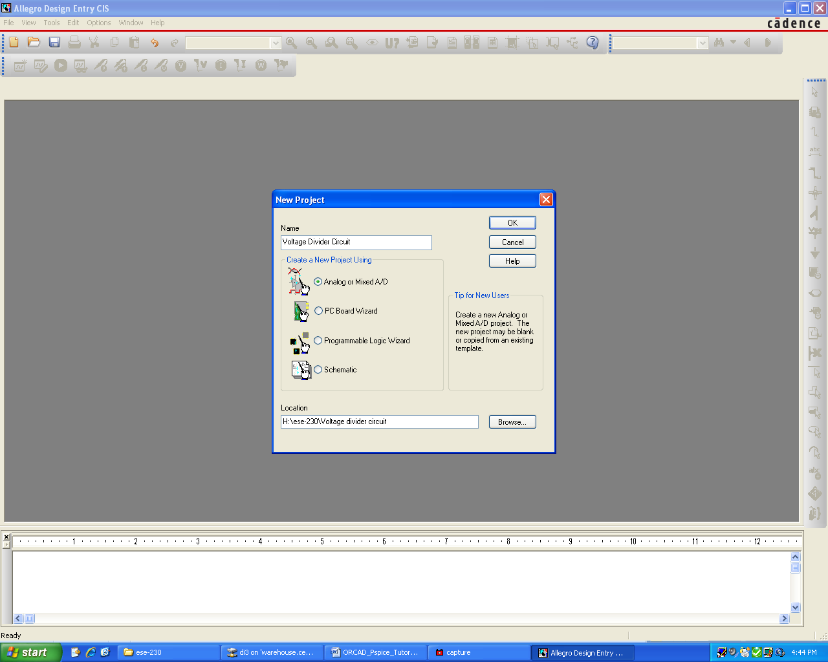
I decided to name my project “Voltage divider circuit”. Notice I have entered the Location of the folder where the schematics and my simulation results will be saved. Use the Browse button to select the location where you would like to save your files. Make sure the Analog or Mixed A/D option has been selected. You may then click the OK button.
The following dialog box will appear.
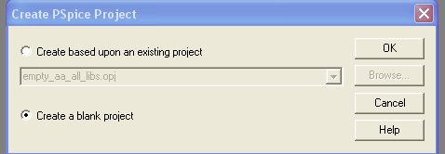

Make sure to select Create a blank project and then click OK button. The following will appear.
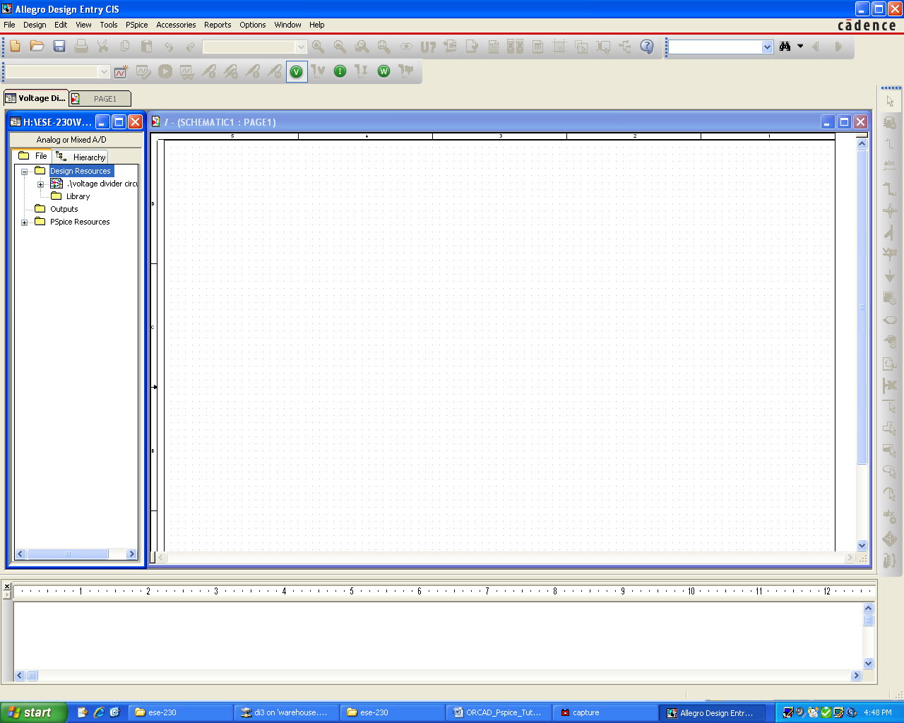
This is ORCAD schematic window. We can create electrical circuit here. Let’s create a simple voltage divider i.e. two resistors, each with a value of 10KΩ. We will drive the series combination with 10V DC voltage and observe the voltage at node between the two resistors. Voltage division principles tell us that the voltage should be half of the input voltage. In our circuit it should be 5VDC.
From the menu at the top, select Place and then Part or click on the second button from the top on the right side vertical bar menu. The following dialog box will appear.
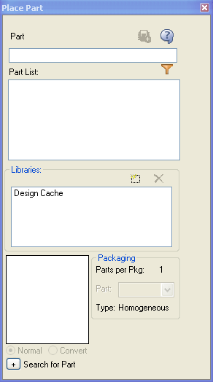
Left click on this rectangular to select Library.
Left click on this rectangular to select Library.

You should select the ANALOG option in Libraries. Then you should select R which is resistor component from the Parts List as shown below.
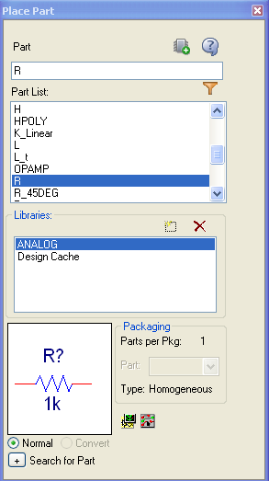
Click on this icon to place the part
Place component by clicking somewhere near the middle of the schematic page. Click again and place R2. You should then right mouse click and select End Mode to exit the place mode (or hit Esc key). The resistor R2 should still be selected as is shown on the next page.
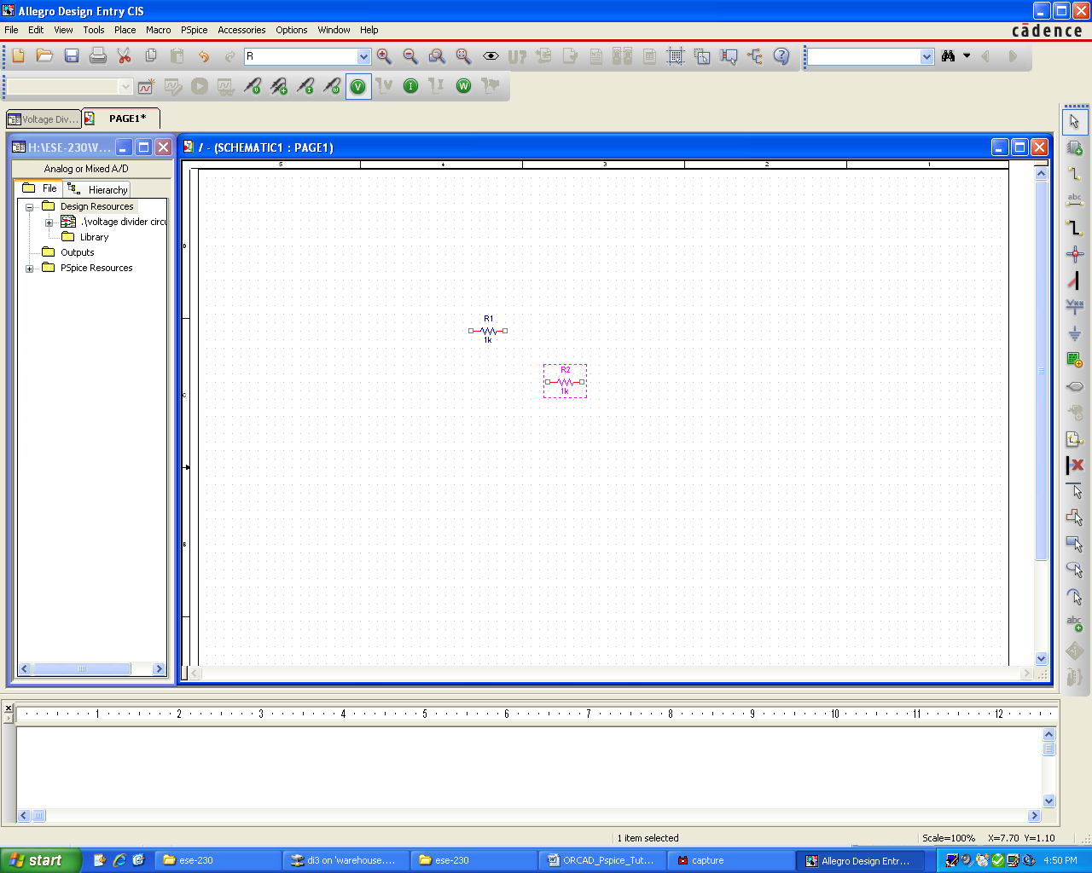
With resistor R2 selected, right mouse click on it. A menu will appear. Select the Rotate option. You should observe the following.
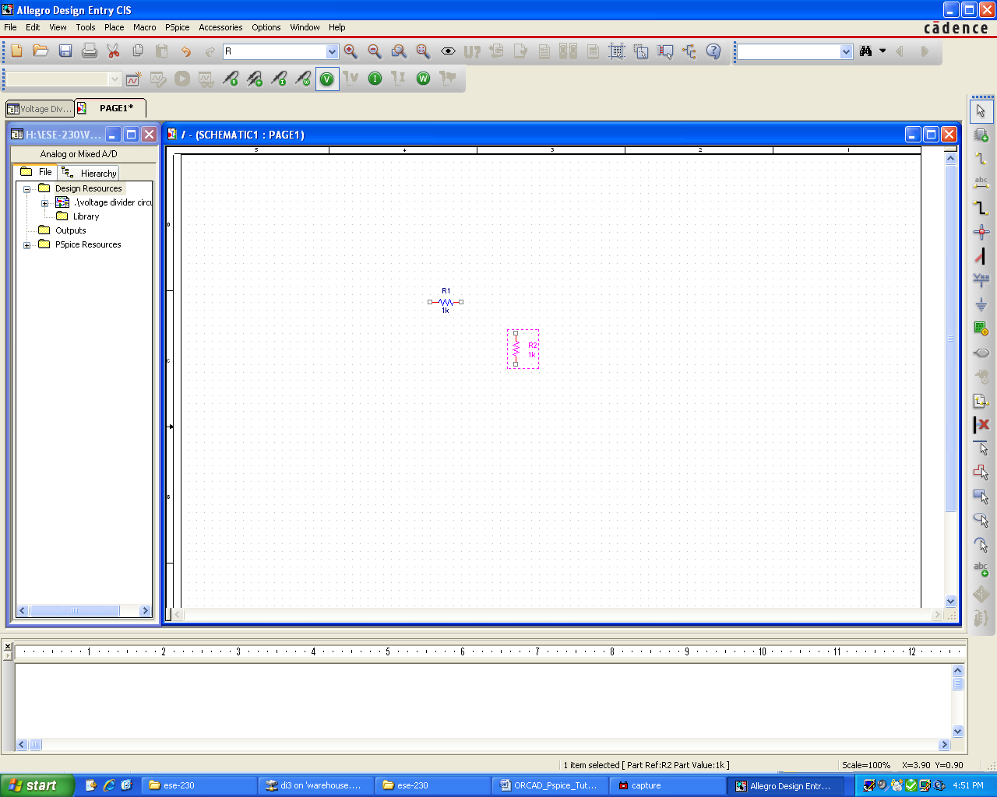
Left mouse click on value on the R1 component. Then right mouse click on the R1 component value. A menu will appear. Select Edit Properties. The dialog box below will appear. Change the value to 10K. Hit OK button.
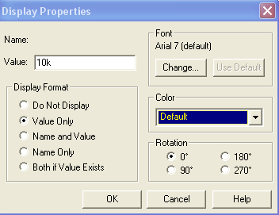
Do the same for the R2 component.
At this point we should probably save our work. This can be done by clicking on the diskette icon in the toolbar or by going to the File menu and selecting Save.
Do a Place Part again. This time use the SOURCE Library. From the SOURCE Library, select VDC as shown below.
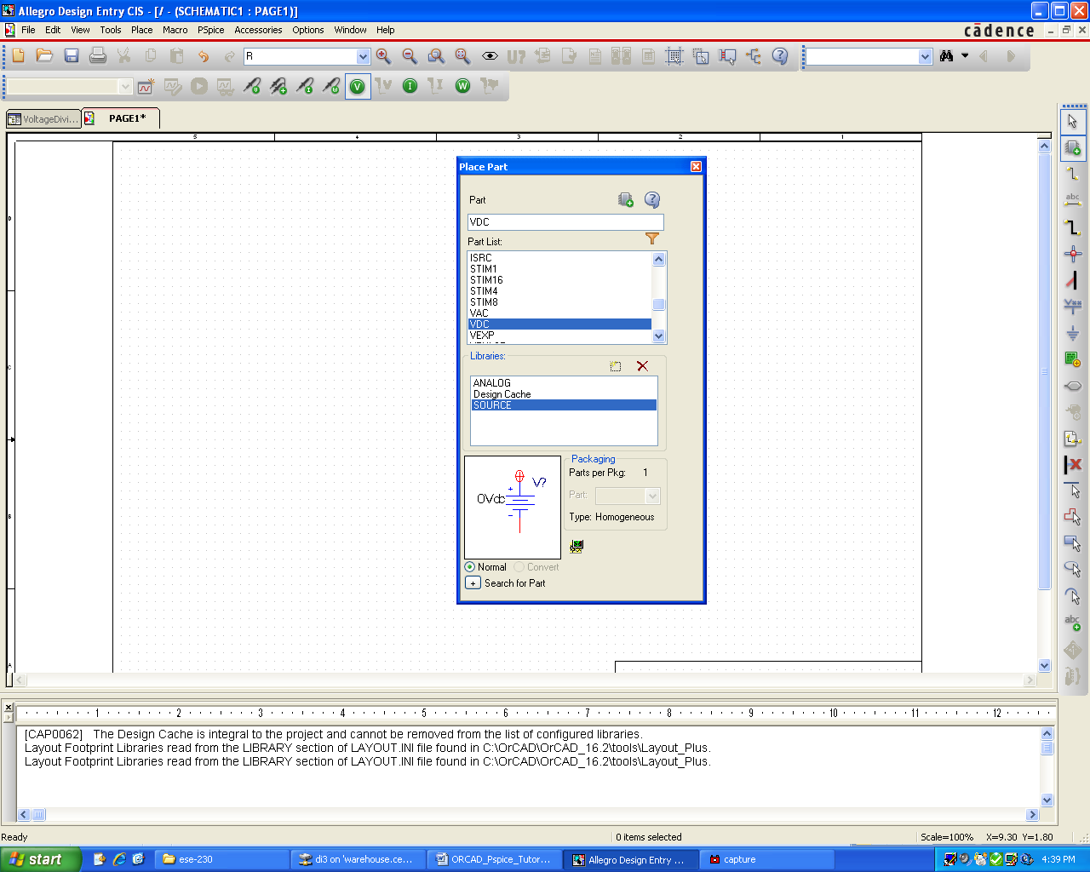
Place the DC (Direct current) voltage source and change the parameter value to be 10VDC.
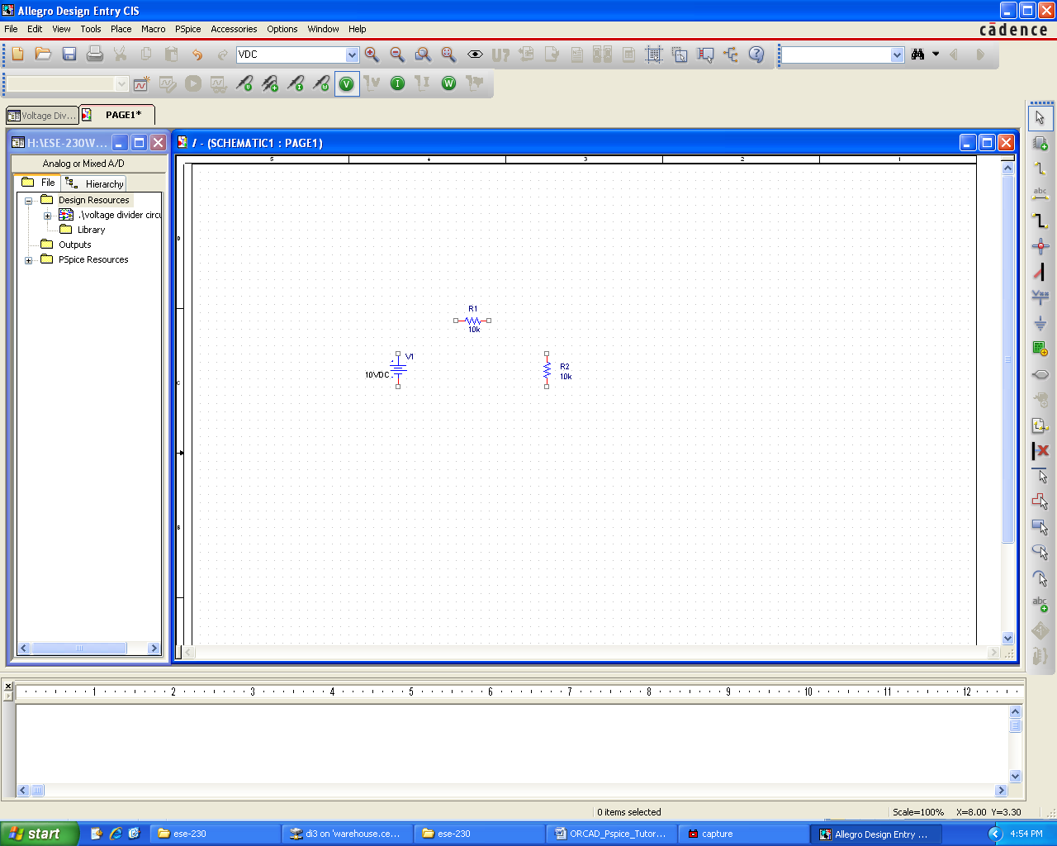

Now place the ground symbol. Chose Place and Ground. Use the 0/CAPSYM symbol. Note that any of the grounds would work but you would need to change GND name to 0. Click OK button.
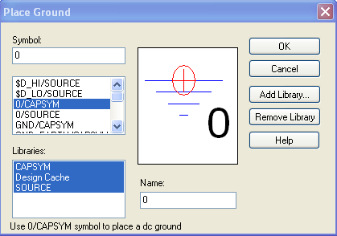
Your circuit should look like the figure below.
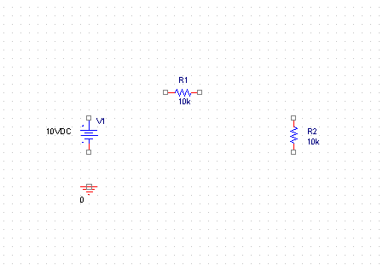
It is now time to wire the components to one another. This can be done by placing a wire. Select Place and Wire to start wiring the circuit components. Click on a pin then drag to mouse to another pin and click again. When the components are all wires together, leave the wiring mode by hitting Esc key.
Your circuit should look like this:
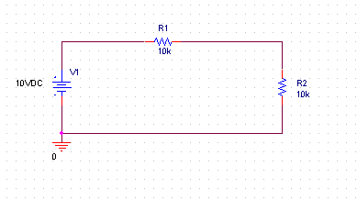
We now are ready to simulate the circuit. We must first prepare a simulation profile where we describe how we want the simulation to be performed. To do this select PSpice and then New Simulation Profile.
The following dialog box appears. I have entered a name for the simulation. I decided to call it tran. You may call it anything you wish. Click on the Create button to create the profile.
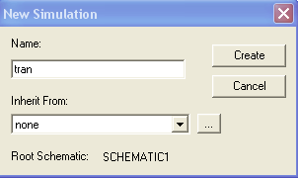
After clicking on the Create button, the following dialog box will appear. Note that I selected Run to time to be 1s.
I also want to have 1000 data points therefore Maximum step size is 1ms (i.e. 1s = 1000ms). Click on OK button.

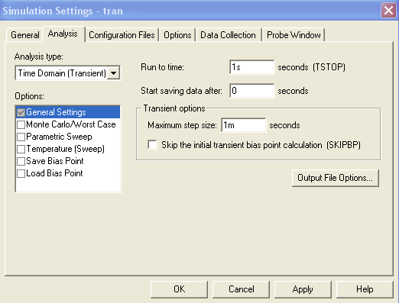
We also need to tell PSPICE which nodes we would like to plot. We do this by going to the main menu bar and selecting PSpice. We then select Markers and Voltage level. We place the marker on the output of the voltage divider as shown below.
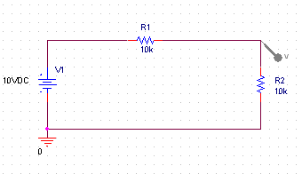
For comparison purposes, let’s also place a marker on the input node as illustrated in the figure below.
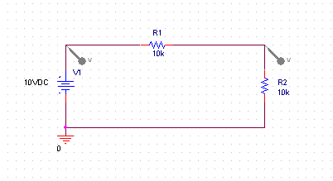
At this point we should probably save our work. This can be done by clicking on the diskette icon in the toolbar or by going to the File menu and selecting Save.
We are now ready to run the PSPICE simulation. We do this by selecting PSpice from the menu bar and then Run. We could also click on the arrow icon on the toolbar. After a few second another window will open and you will see the following simulation traces.
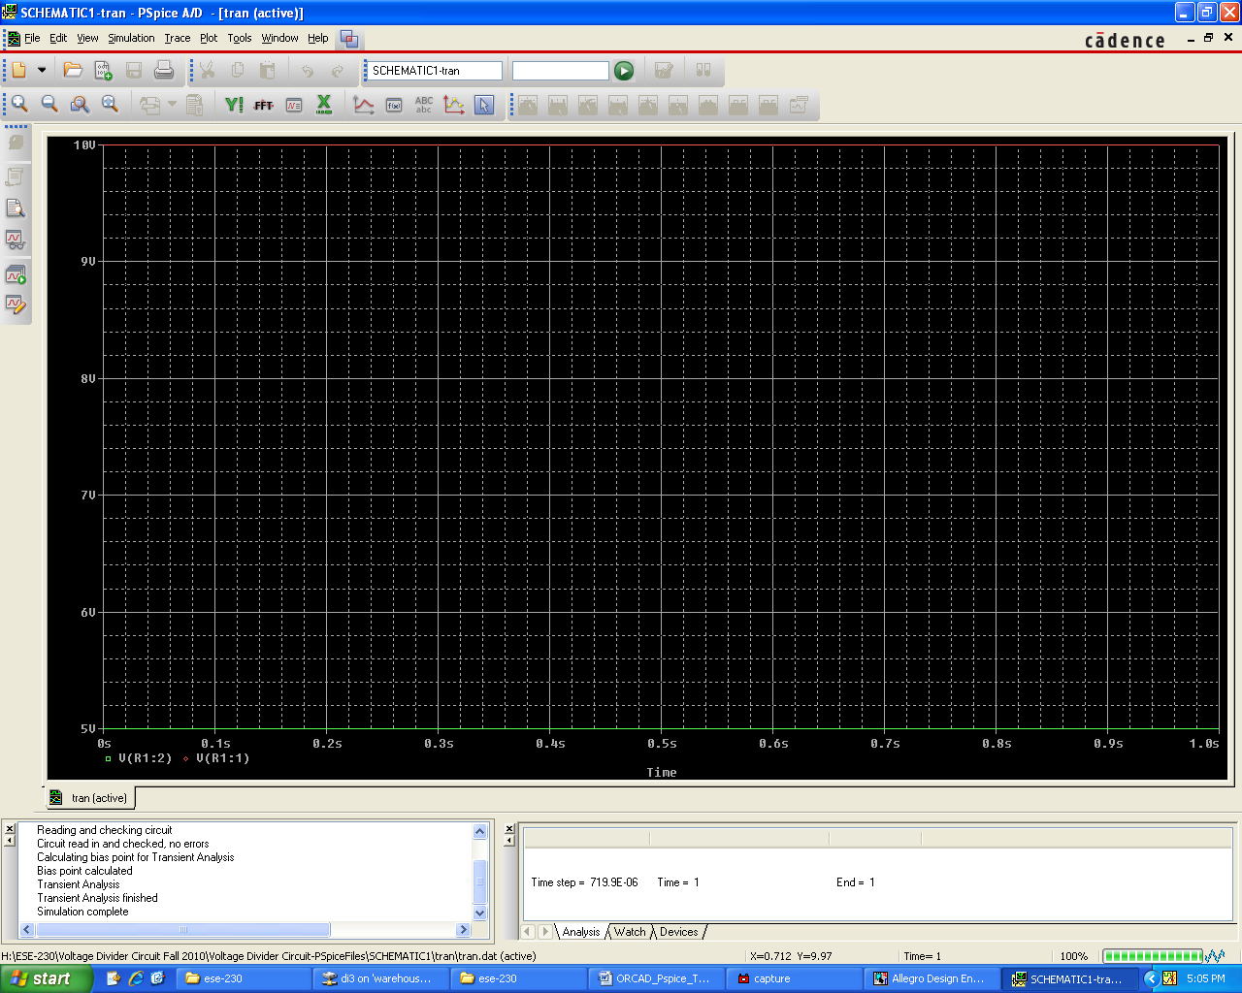
We can make this graph look a little bit nicer by changing Y-axis. Select Plot and then Axis Settings… from the menu bar. The following dialog box will appear.
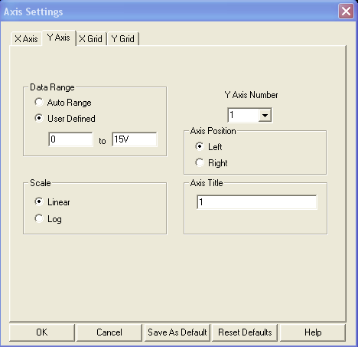
Select Y Axis and select User Defined and then change range from 0 to 15V. Hit OK button and the graph will change as shown below.
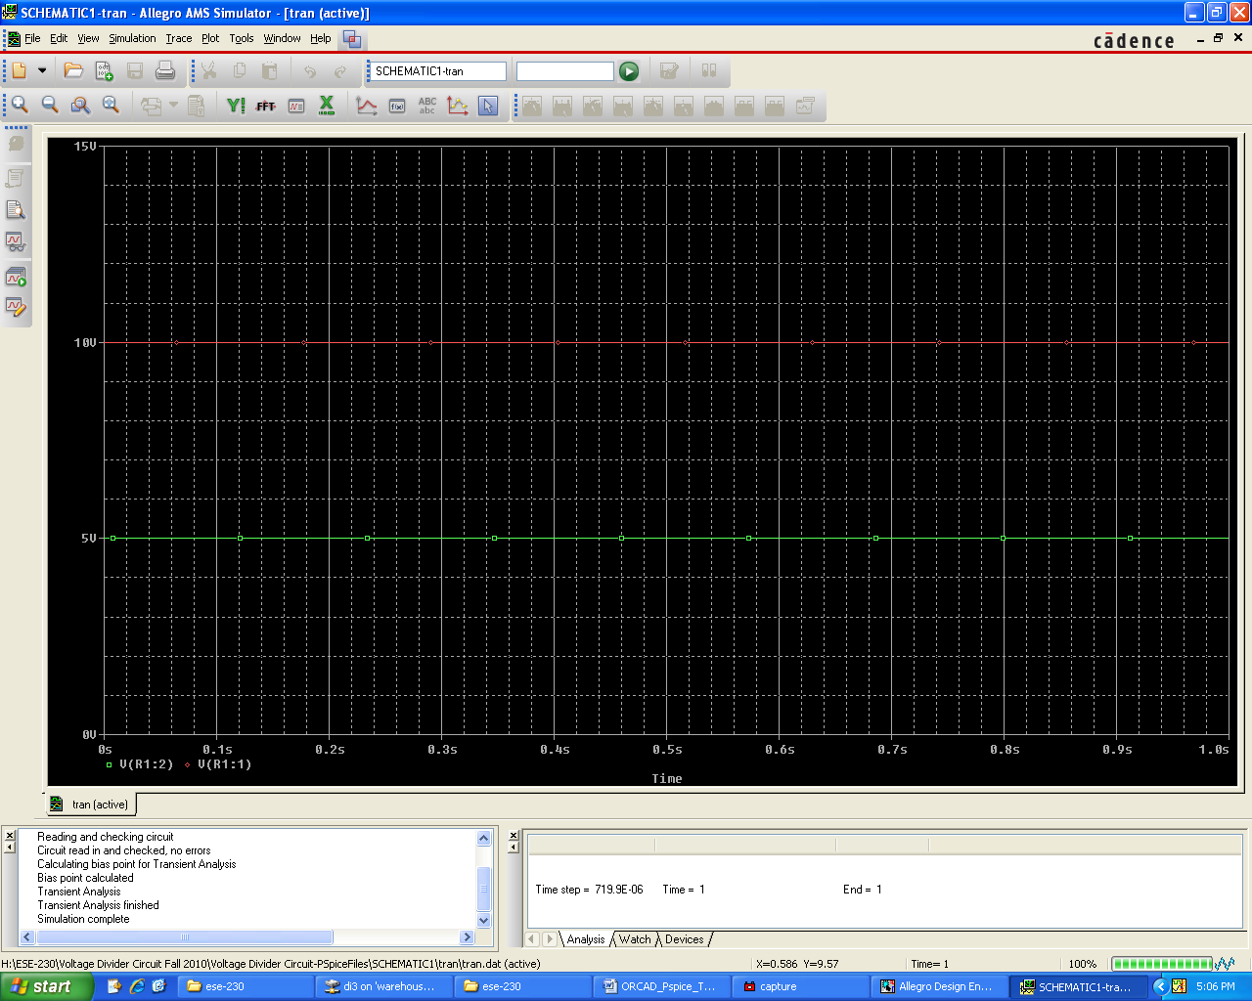
Notice the green trace (output) has one-half the amplitude of the red trace (input) as we predicted.
Congratulations!!! You have successfully run PSpice to simulate a simple voltage divider.

