Exercise DP.5 Completing the Simulation
You are now ready to incorporate a recycle structure to the flowsheet. We have delayed this till now because recycle involves iterative calculations in HYSYS. Typically a value is assumed for a recycle stream (or another intermediate stream called a tear stream) and the calculations are done block by block. This is called sequential modular simulation. After all the blocks have been calculated the computed value of the recycle stream flows is compared against the guessed values. If they are not the same, then a new guess is generated and the cycle of calculations is repeated. This may take a few iterations around the recycle loop.

Part I. Adding recycle stream.

Start with the run from DP5. Add the mixer, pump and recycle blocks as shown in Figure 1. It will also be necessary to add a pump to increase the pressure in the recycle stream to 300 psia.

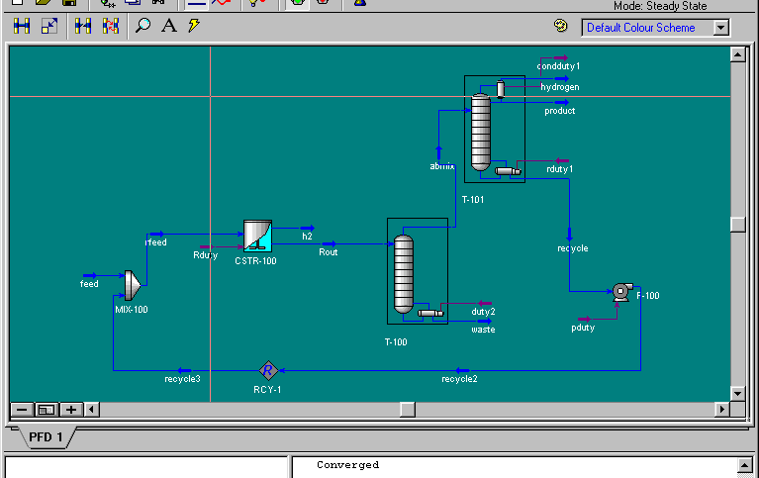
Figure 1:
Process Flow Diagram

Questions:

- How many iterations does it take to converge the recycle calculations?
- What is the effect of changing the reactor temp from 200 to 180 on the recycle flow rate? Do you think this might be a better operating temperature? Why or why not?
Part II. Adding Energy change operations

The next step in the simulation is to add the energy change operations.

See Figure 1 and Table 1 with all pumps, heat exchangers and other units incorporated. A description of each unit is given below. Use this to complete your flowsheet. See also attached printout for a clearer view.

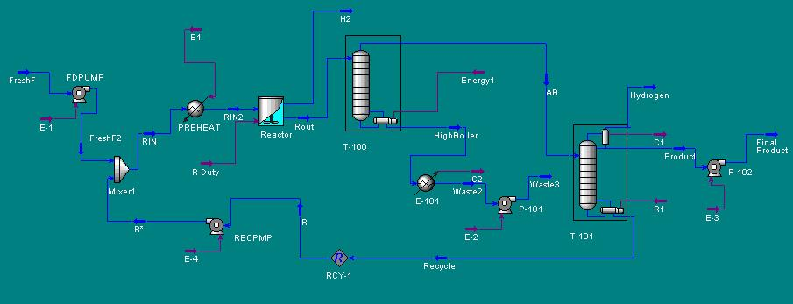

Figure 1:Process Simulation with Energy Intergration

Table 1:
Description of Process Elements

Block Name | Model | Description and specs
FDPUMP | PUMP | This PUMP is used to increase the pressure of the feed stream from 14.7 psia to 300 psia required in the reactor. Go to the streams menu and make sure you have specified the feed as coming in 77 F and 14.7 psia.
RECPMP | PUMP | To increase the pressure of the recycle stream to 300psia.
E-100 | HEATER | To heat the reactor feed to 200 F at 300 psia
E-101 | HEATER | To cool the waste stream to 110 F before pumping to storage. Pressure should be 14.7 psia.
P-100 | PUMP | To increase the pressure of the waste stream to 30 psia
E-102 | Heater | To cool product to 110 F
prodpump | PUMP | To pump product to 20 psia

Check your simulation for completeness. Specify any missing data. Save your work. Then submit the run. Study the results. Create a stream table and print it.

HYSYS Report requirements

- Submit a stream summary table report as shown in attached. Compare and verify your numbers. Note any differences and explain why.
- Prepare a summary table of energy requirements: electricity, heating and cooling requirements.

