Exercise DP.5 Rigorous Design of the Column
As mentioned earlier, the results from the short cut distillation method are preliminary, and should be verified using a rigorous simulation model in HYSYS. The specifications required for this model are quite different. The complexity of the model requires you to specify the input with some care and thought. A very common problem encountered is the inability of the column calculations to converge. The failure to converge can be caused by many reasons including:

1. Poor initial guesses for tray temperatures and flow rates
2. Convergence method used is not the best choice
3. Improper column specifications (The purity specified cannot be met by changing the variables specified)
4. The separation specified is not achievable due to thermodynamics (Formation of an azeotrope for example).

To start, delete the short cut column and attach a Distillation Column to your simulation as shown in Figure 1.

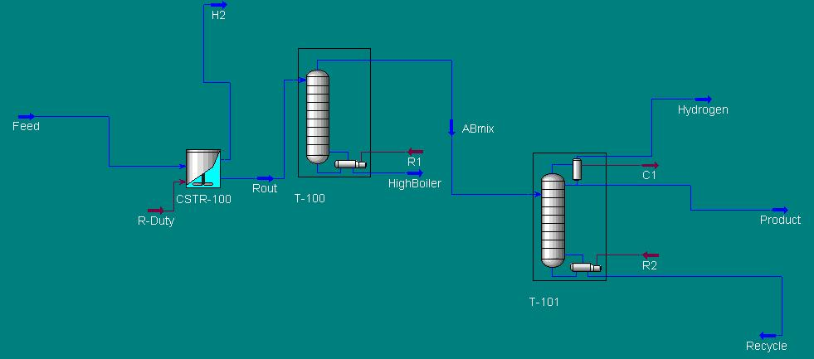

Figure 1: Flowsheet for distillation design

Note: T-101 has a partial condenser. This is necessary to prevent the condenser from trying to condense any hydrogen that may still be present. Thus, the stream labeled Hydrogen is the vapor stream and the stream labeled product is the liquid stream. Check your flowsheet to make sure this is indeed the case.

Enter the following results that obtained from the preliminary design.

On the Connections Page:

- Label all Column Streams as shown in Figure 1.
- Number of Stages = 33
- The feed should enter on stage 11.
- Condenser = Partial Vapor

Temperature Estimate Page:

- Provide a Temperature Estimate for the 1st stage and the Reboiler of 215 ºF and
240 ºF

Pressure

The pressure in the reboiler and condenser should be specified as 3 psi.

On the Specifications Page:

If the following specifications are not listed in the Column Specifications window then you will need to add them. We are interested in: Reflux Ratio, Overhead Vapor Rate, and the Component Fraction of cyclohexanone in the stream labeled product. The numerical values of the above specifications are listed below.

Reflux Ratio = 10.00
Overhead Vapor Rate, or Vent Rate = 0.50 lbmole/hr ( This should remove all the hydrogen and some cyclohexanone in the vapor)
Comp Fraction of Cyclohexanone on the Condenser Stage = 0.95

On the Design Page:

1) Make sure that the three specifications are selected as Active.

If the Column does not run automatically, Click the Run button and then the column should converge.

Compare your specification values with those shown in Figure 2.

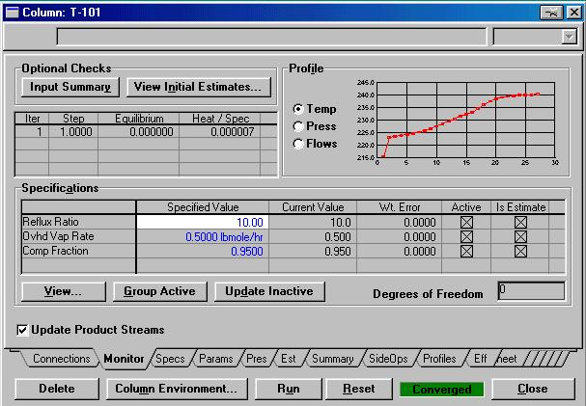

Figure 2: Monitor Page

Answer the following questions:

1) What is the recovery of the light key in the distillate? What is the purity?

- What is the mole purity of product and recycle streams? Does it meet specifications of 95% purity?

- What is the purity of the bottoms stream? Changing the reflux ratio if needed can change the purity of this stream. Is it necessary? Why or why not?
Save your run.
- Suppose you want to withdraw the product as a liquid distillate. Disconnect the Product stream and reconnect as a liquid distillate stream. Change the specs on Column menu to a total condenser. Make a run. What happens? Why?
Reset your column back as before by loading the saved run.

- ( Optional) Under vacuum conditions some air will leak into the system. Assume that 10 lb./hr of air leaks into the column. How will it affect your column operation? Incorporate the air in the feed stream and add a product condenser on the distillate vapor stream coming out of the column. A heater model can be used to model the condenser. With cooling water available at 70 F we can cool the product down to about 120 F easily. Note the condition of the stream leaving the heater block. What fraction is vapor? Separate the product liquid from the non-condensable air and hydrogen using a flash drum. What is the value (in $/yr. ) of the product lost with the non-condensable stream? How can we reduce this loss?

