DP.4. Separation of Product and Recycle

The next step is to design a separation column to purify the product and to recover any unreacted cyclohexanol for recycle.

We will attempt to separate the AB mixture using distillation first. If it turns out to be infeasible then we can try other schemes. Due to the similarity in the molecular structure of A and B they will have very similar physical properties. As we saw earlier, their vapor pressures are almost identical and they could very well form an azeotrope. If that is the case then distillation would fail. We will start by doing some preliminary calculations using a short cut ( approximate) model that is easy to use. Next we will verify that our initial estimates are correct using a rigorous model of the column.

Part I. Short cut design

Start by opening up your simulation from last week. A shortcut model is provided by Hysys to estimate the number of stages needed.

Step 1. Click on the Short Cut Distillation Button from the Object Palette. Complete the Screen as shown in Figure 1. Be sure to select the top product as being vapor.

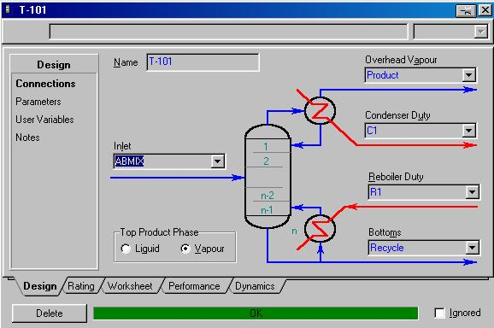
Figure 1:

Design Screen for Short Cut Distillation
Step 2. Click on Parameters under Design. The following information needs to be inputted:

Light key Cyclohexanone in Bottoms = 0.05
Heavy Key Cyclohexanol in Distillate = 0.05
Condenser Pressure = 14.7 psia
Reboiler Pressure = 14.7 psia
External Reflux Ratio = 1.4 times the minimum reflux ratio.

This completes the short cut distillation design. Results for the number of stages as well as the condenser and reboiler duties can be viewed by clicking on the performance tab.

Questions to be answered in your report.

- Please include a stream summary in your report. Make sure you have entered your name properly in the report page. It should appear on the top right half of your report.
- How many stages are required for the separation?
- Since column requires an unusually large number of stages we will try to reduce this by changing the column pressure. Try operating the column at 3psia. How many stages are needed now? Why the difference.
- What is the penalty paid for operating the column at a lower pressure? In other words why does it cost more to operate the column at a lower pressure?
- At 3psia, what is the reboiler duty? Condenser duty? Also note the reboiler and condenser temperatures.
- What is the effect of increasing the purity of the product stream? Look at the change in number of trays if we want to make the product 96,97, 98 and 99% pure.

The next step in our process simulation is to implement the short cut distillation results in a rigorous distillation design.

Part II. Rigorous Design of the Column
As mentioned earlier, the results from the short cut distillation method are preliminary, and should be verified using a rigorous simulation model in HYSYS. The specifications required for this model are quite different. The complexity of the model requires you to specify the input with some care and thought. A very common problem encountered is the inability of the column calculations to converge. The failure to converge can be caused by many reasons including:

- Improper column specifications, such as incorrect pressure gradients.
- Poor initial guesses for tray temperatures and flow rates
3. Convergence method used is not the best choice
4. Improper column specifications (The purity specified cannot be met by changing the variables specified)
5. The separation specified is not achievable due to thermodynamics (Formation of an azeotrope for example).

Step 1. Save your previous run as DP4a.
Delete the short cut column and attach a Distillation Column to your simulation as shown in Figure 1.
Save your new run as DP4b.
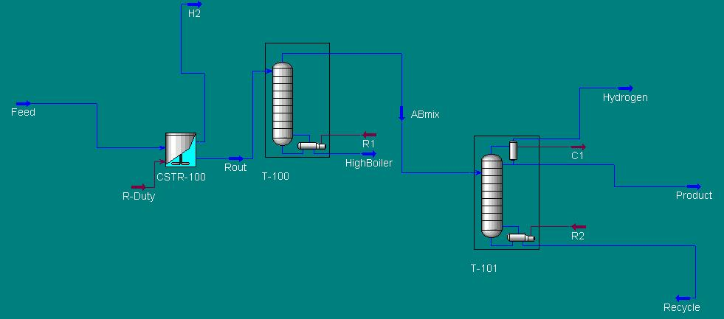

Figure 1: Flowsheet for distillation design

Note: T-101 has a partial condenser. This is necessary to prevent the condenser from trying to condense any hydrogen that may still be present. Thus, the stream labeled Hydrogen is the vapor stream and the stream labeled product is the liquid stream. Check your flowsheet to make sure this is indeed the case.

Step 2. Enter the following results that obtained from the preliminary design.

On the Connections Page:

- Label all Column Streams as shown in Figure 1.
- Number of Stages = 33
- The feed should enter on stage 11.
- Condenser = Partial Vapor

Temperature Estimate Page:

- Provide a Temperature Estimate for the 1st stage and the Reboiler of 215 ºF and
240 ºF

Pressure

The pressure in the reboiler and condenser should be specified as 3 psi.

On the Specifications Page:

If the following specifications are not listed in the Column Specifications window then you will need to add them. We are interested in: Reflux Ratio, Overhead Vapor Rate, and the Component Fraction of cyclohexanone in the stream labeled product. The numerical values of the above specifications are listed below.

Reflux Ratio = 10.00
Overhead Vapor Rate, or Vent Rate = 0.50 lbmole/hr ( This should remove all the hydrogen and some cyclohexanone in the vapor.
Comp Fraction of Cyclohexanone on the Condenser Stage = 0.95

On the Design Page:

1) Make sure that the above three specifications are selected as Active.

If the Column does not run automatically, Click the Run button and then the column should converge.

Compare your specification values with those shown in Figure 2.

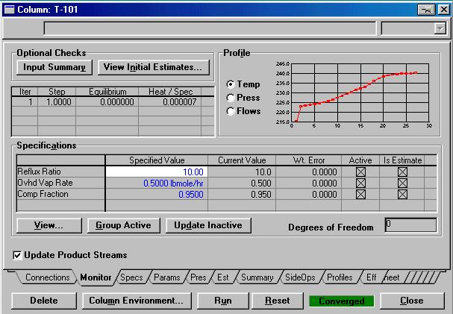

Figure 2: Monitor Page

In your report, answer the following questions:

- Include a stream summary and a copy of your flowsheet. Make sure your name appears on the report page.
- What is the recovery of the light key in the distillate? Recovery is fraction of feed that is recovered in the distillate.

- What is the mole purity of product and recycle streams? Does it meet specifications of 95% purity? How much C is recycled?
- How much product is lost with the Hydrogen stream exiting the column? What is its annual value $/yr?
- We would like to reduce the loss of product in hydrogen stream. Add a spec to the column that says the hydrogen stream should contain 70% hydrogen. Note that this is a component purity specification on a stream. I think you can figure out how to do this. Note that if you add a spec you must release an active spec to keep the number of degrees freedom equal to zero. Which column spec would you release
Now compute the loss of product in hydrogen in $/yr.

Save your run.
- Suppose you want to withdraw the product as a liquid distillate. Disconnect the Product stream and reconnect as a liquid distillate stream. Change the specs on Column menu to a total condenser. Make a run. What happens? Why?
Reset your column back as before by loading the saved run.

- Under vacuum conditions some air will leak into the system. Assume that 10 lb./hr of air leaks into the column. Comment on the fate of the air leaking into the system. Where will it end up? How would it affect our economics? Would we have to worry about it?
- ( Optional, Extra credit problem) Incorporate the air in the feed stream and add a product condenser on the distillate vapor stream coming out of the column. A heater model can be used to model the condenser. With cooling water available at 70 F we can cool the product down to about 120 F easily. Note the condition of the stream leaving the heater block. What fraction is vapor? Separate the product liquid from the non-condensable air and hydrogen using a flash drum. What is the value (in $/yr. ) of the product lost with the non-condensable stream? How can we reduce this loss?

