DP7. Energy Intergration

The next step in the simulation is to add the energy change operations.

See Figure 1 and Table 1 with all pumps, heat exchangers and other units incorporated. A description of each unit is given below. Use this to complete your flowsheet.

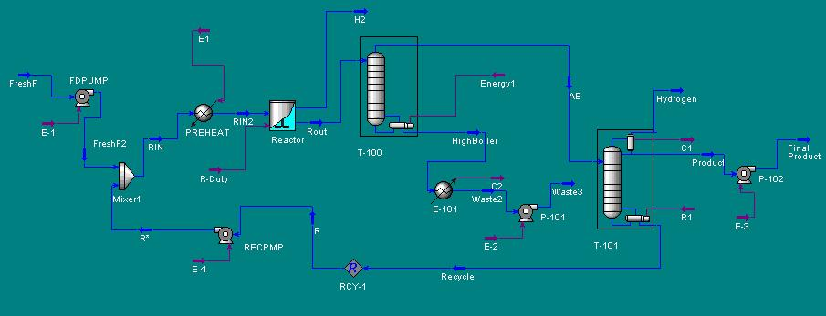

Figure 1:
Process Simulation with Energy Intergration

Table 1:
Description of Process Elements

Block Name | Aspen Model | Description and specs
FDPUMP | PUMP | This PUMP is used to increase the pressure of the feed stream from 14.7 psia to 300 psia required in the reactor. Go to the streams menu and make sure you have specified the feed as coming in 77 F and 14.7 psia.
RECPMP | PUMP | To increase the pressure of the recycle stream to 300psia.
RPREHEAT | HEATER | To heat the reactor feed to 200 F at 300 psia
WASTCLR | HEATER | To cool the waste stream to 110 F before pumping to storage. Pressure should be 14.7 psia.
WASTPUMP | PUMP | To increase the pressure of the waste stream to 20 psia
PRODPUMP | PUMP | To pump the product from GASSEP to 20 psia.

Check your simulation for completeness. Specify any missing data. Save your work. Then submit the run. Study the results. Create a stream table and print it.

HYSYS Report requirements

- Submit a stream summary table.
- Prepare a summary table of energy requirements: electricity, heating and cooling requirements.

Homework requirements:

- These results are to be used to complete your sizing and costing calculations for the cyclohexanol process. Go through and size each equipment. Then enter this data into CAPCOST program and estimate the total capital cost requirements of the plant.

- Estimate the following manufacturing cost estimates $/year basis. Round of to the nearest 1000.

- electricity costs
- steam costs
- cooling water costs
- raw material costs
- sales income
- operating labor costs
- total manufacturing cost for the product.
- Net cash flow from the project assuming 35% tax, 10 year straight line depreciation.
- value of raw material and product lost $/yr in each of the side streams exiting the process. This includes the waste stream, the hydrogen stream leaving the reactor and the noncondensable leaving the column.

Based on your study of the above results suggest areas of improvement in the process design that would lead to significant reduction in costs. For example would it help to add a vapor recovery system to the hydrogen stream to recover the A and B? , Change operating condition in reactor or flash drum, etc.

