DP.3. Gas and Waste Separation

For these and subsequent runs use a reactor operating at 200F and 300 psia from previous run.

The next step in the design is to think about gas and liquid separation structures. In this problem, the hydrogen produced in the reactor will be removed from the reactor itself as a gas. The CSTR model allows us to specify separate gas and liquid outlet streams. The remaining liquid stream (Rout) is mostly A and B with a small amount of high boiler. The separation of A and B is going to be difficult since these two compounds have similar physical properties. The high boiler on the other hand has a much higher boiling point as shown by our vapor pressure calculations earlier. Based on this we can safely conclude that the best strategy is to remove the high boiler by boiling A and B by boiling it off. To achieve the purity desired we will use a reboiled absorber.

To keep the boiling points low we can drop the pressure to near 1 atm. Upon completion your PFD should appear as shown in Figure 1.

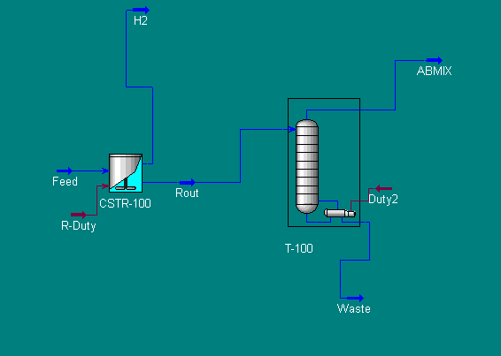

Figure 1:
Separation of High Boiler using Reboiled Absorber

Reboiled Absorber Design:

- Open your file from last week, check reactor temperature and pressure. Add the unit operation Reboiled Absorber by double clicking on it in the sidebar menu.
- Specify the bottoms, overhead, and energy stream as shown in Figure 1. Specify the number of stages as 2. We can change these later if we wish.
- Click on the Next button and specify both the Top Stage and Reboiler Pressure as 14.7 psia.
- Click Next button and enter estimated top temp as 200 and bottom temp as 300 F.
- Click Next button and enter boilup ratio ( ratio of bottoms flow to vapor flow) as 1.00. This is an initial estimate.

- Double Click on tower and then click on Column Environment. You will be now in the subsection of the process with only the column visible. We will complete the design of the column and then return to the process environment. Go to the Specs page.
- We are going to specify the Component Recovery in stream ABMIX. To do this click on the Add button. Choose Component Recovery. Specify following:
Draw: ABMIX
Spec Value: 0.95
Components: Cyclohexanone
This specifies that we want to recover 95% of the cyclohexanone ( in the feed ) in the top vapor stream, ABMIX.
- From the Design Page, make sure Component Recovery is Active under the Specifications. There can be no other specifications Active. The tower should run automatically, if not click on the Run button. This completes the simulation

Report requirements:

Include a stream summary in your report.

Answer the following Questions:

- How much A and B are lost with the Hydrogen gas? Compute its value in $/year using the cost figures given in the problem statement. Is this an acceptable loss? To answer this question compare against the economic potential computed in the previous workshop. Note: If the loss of A & B in vapor stream were large, then we can recover these by a number of techniques.

(a) cooling and condensation
(b) absorption in a solvent
(c) adsorption

(If the vapor stream is to be discharged into the atmosphere, we may need to install recovery systems to meet environmental regulations). For now assume that we can dispose of the hydrogen as fuel gas at no cost.

- What is the value of A and B lost in the Waste stream? Express in $/yr. Is this significant? How can we recover more of the A and B ? List possible options. If possible try some in your simulation and report the results
- What is the loss in revenue caused by the production of C? Is this significant? You can reduce loss of C by changing the reactor operating conditions. We will do this later as part of our optimization calculation.

- We will next put in a distillation column to separate the cyclohexanone from the cyclohexanaol. The cyclohexanol will be recycled back to the reactor. What will happen to the high boiler carried with the ABMIX stream? Will it appear in the product stream? Explain your answer.

- Study the effect of changing the recovery specification on the column ( Note that in the above we specified the recovery as 95% of all entering A should be recovered in the ABMIX stream) on ( 1) the amount of A and B that is lost in the waste stream ( compute in terms of the value of A and B lost with the waste stream in $/year), and (2) the amount of High boiler in the ABMIX stream. Vary the recovery from .93 to .98 in increments of 0.01. Do this as a case study, graph the result and submit with the report.

Refer to the last workshop on how to do sensitivity studies.

- If time permits ( optional, extra credit problem) study the effect of changing the number of stages. What is the economic significance of this variable?

- ( Extra credit problem) If time permits try to use a flash to remove the high boiler. Can we achieve the separation desired? Why or why not? A flash will be lot less expensive than a reboiled absorber.

